**PROJECT DEVELOPMENT PHASE ( DELIVERY OF SPRINT-1)**

|  |  |
| --- | --- |
| **Date** | **18th November 2022** |
| **Project Name** | **Car Resale Value prediction** |
| **Maximum marks** | **4 Marks** |

Import Library and load the data set:

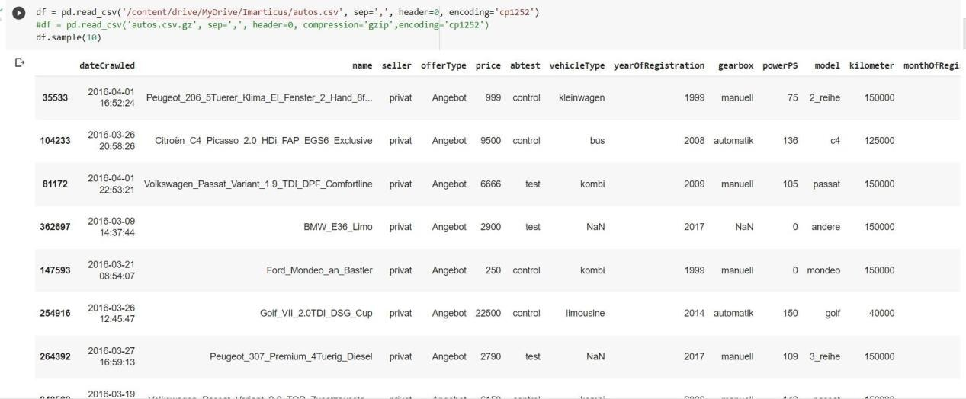

Understanding and analyzing the dataset by Correlation:

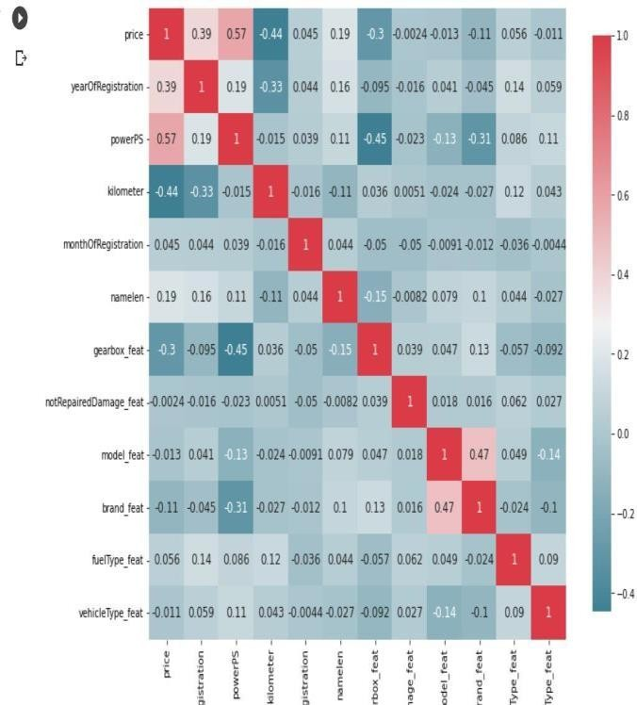

Clearing the null values:

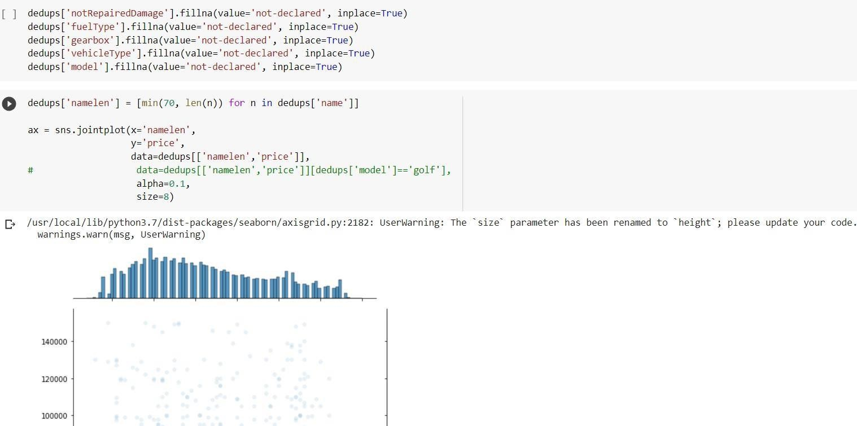

Preprocessing the Categorical values:

